**Introduction to Swing Classes**

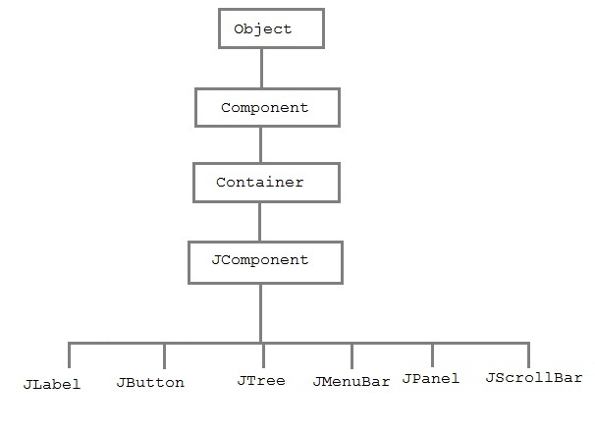

## Swing Components and the Containment Hierarchy

JFrame (a top-level container)

|

...

|

content pane

|

JPanel

|

+----------------+

| |

JButton JLabel

**Creating a JFrame**

JFrame is Swing's version of Frame and is descended directly from **Frame** class. The component which is added to the **Frame**, is refered as its Content.

There are two way to create a JFrame Window.

1. By instantiating JFrame class.
2. By extending JFrame class.

**Creating JFrame window by Instantiating JFrame class**

import javax.swing.*;

import java.awt.*;

public class First

{

JFrame jf;

public First() {

**jf = new JFrame("MyWindow")**; //Creating a JFrame with name MyWindow.

JButton btn = new JButton("Say Hello"); //Creating a Button.

jf.add(btn); //adding button to frame.

jf.setLayout(new FlowLayout()); //setting layout using FlowLayout object.

jf.setDefaultCloseOperation(JFrame.EXIT_ON_CLOSE); //setting close operation.

jf.setSize(400, 400); //setting size

jf.setVisible(true); //setting frame visibilty

}

public static void main(String[] args)

{

new First();

}

}

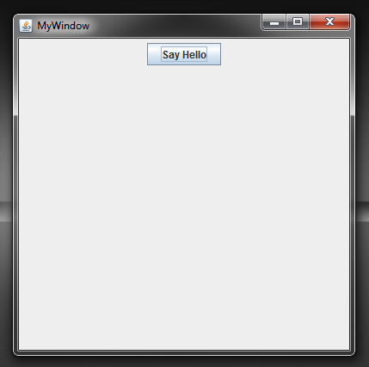

SwingApplication creates four commonly used Swing components:

* a *frame*, or main window (JFrame)
* a *panel*, sometimes called a *pane* (JPanel)
* a button (JButton)
* a label (JLabel)

frame = new JFrame(...);

button = new JButton(...);

label = new JLabel(...);

pane = new JPanel();

pane.add(button);

pane.add(label);

frame.getContentPane().add(pane, BorderLayout.CENTER);